Lab 8 Ernest Sebastian. Submission

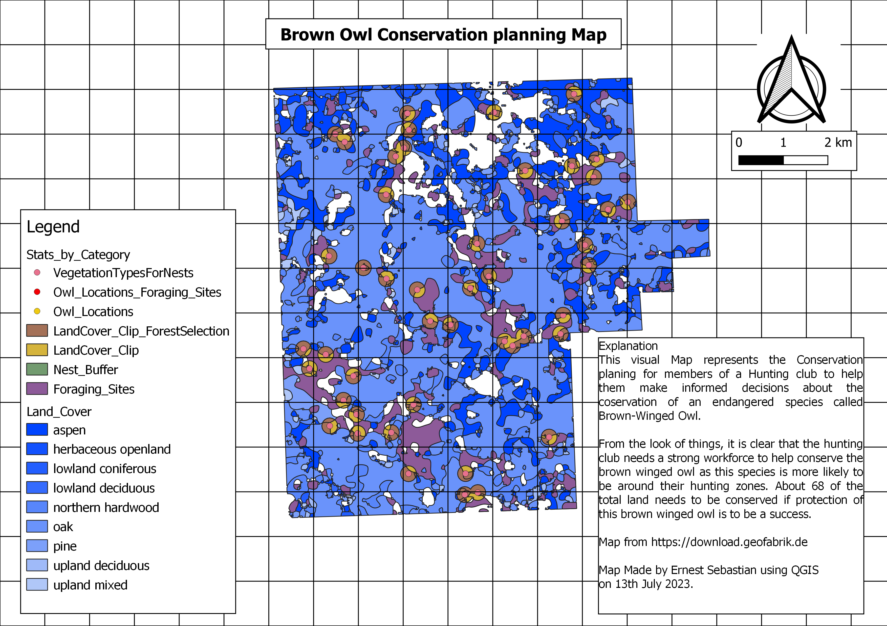

**Questions**

1. Are the point files displayed in QGIS in shape file format? Where are they saved? How can you tell? What do you think happened when you imported them into the project?

Yes, the files displayed in QGIS are saved in shape file format. After importing the files, QGIS converts the files under the hood into the required file system for it to display the coordinates if available and map them to the underlying Map.

1. What do you notice about the distribution of foraging areas in relation to nesting areas?

The relationship is a direct correlation one. Where foraging sites are, nests are also available.

1. What vegetation types are the owls using for nesting?

>> Aspen, Oak, Northern Hardwood, Upland Mixed

1. What percentage of nest locations occur in each cover type?

|  |  |  |  |
| --- | --- | --- | --- |
| Vegetation Cover Type | | Nests Count | Nest Percentage |
| 1 | Aspen | 11 | 23 |
| 2 | Oak | 32 | 68 |
| 3 | Northern Hardwood | 3 | 6 |
| 4 | Upland Mixed | 1 | 2 |

1. Where are possible foraging sites?

>> Herbaceous open land

1. What are the average, minimum, and maximum distances of nest sites from foraging sites?
   * The minimum distance is 0.8m
   * The maximum distance is 303m
   * The average distance is 39m
2. What is the total (Sum) area of the protected forest within the buffer zones?
   * 282.7ha
3. What is the total area of the hunting club, including all land cover types?

* 1266.5Ha

1. What is the total area of the forested areas within the hunting club?

* 865.2 Ha

8. What percentage of the forested area needs to be protected, and therefore, will the hunting club not gain revenue for the timber?

* 68.3% of their forest land.
  + Forested Area = 865.2Ha
  + Total Hunting club area = 1266.6Ha
  + Percentage = (Forested Area / Total Hunting club area) *100 = 68.3%

Reflections and Key Takeaways

Participating in this QGIS lab has been a valuable experience that has enhanced my understanding of how spatial skills can contribute to addressing complex problems in wildlife and forest management. Throughout the lab, I had the opportunity to analyze the nesting locations of brown-winged owls and conduct spatial analyses, enabling me to provide essential information to Windfall Trails Hunt Club regarding habitat conservation and forest management practices. By mapping out owl habitats and identifying their preferred vegetation types, I gained insights into the specific habitat characteristics required for their nesting sites. Moreover, by determining suitable distances between nesting and foraging areas, I was able to offer informed recommendations that strike a balance between the club's need for timber revenue and the conservation of these sensitive species.

This lab vividly demonstrated the practical application of GIS in real-world scenarios, highlighting the importance of considering endangered or threatened species in management activities. I learned that timber harvesting within a defined area surrounding known owl nesting locations is restricted to protect the species. This understanding shed light on the potential challenges faced by landowners who rely on timber revenue for their livelihoods. Some may develop negative attitudes towards sensitive, threatened, or endangered species, as adjusting management plans or land-use activities can be burdensome. However, I also discovered that the presence of these species can be an asset for landowners interested in maintaining biodiversity or exploring eco-tourism opportunities.

